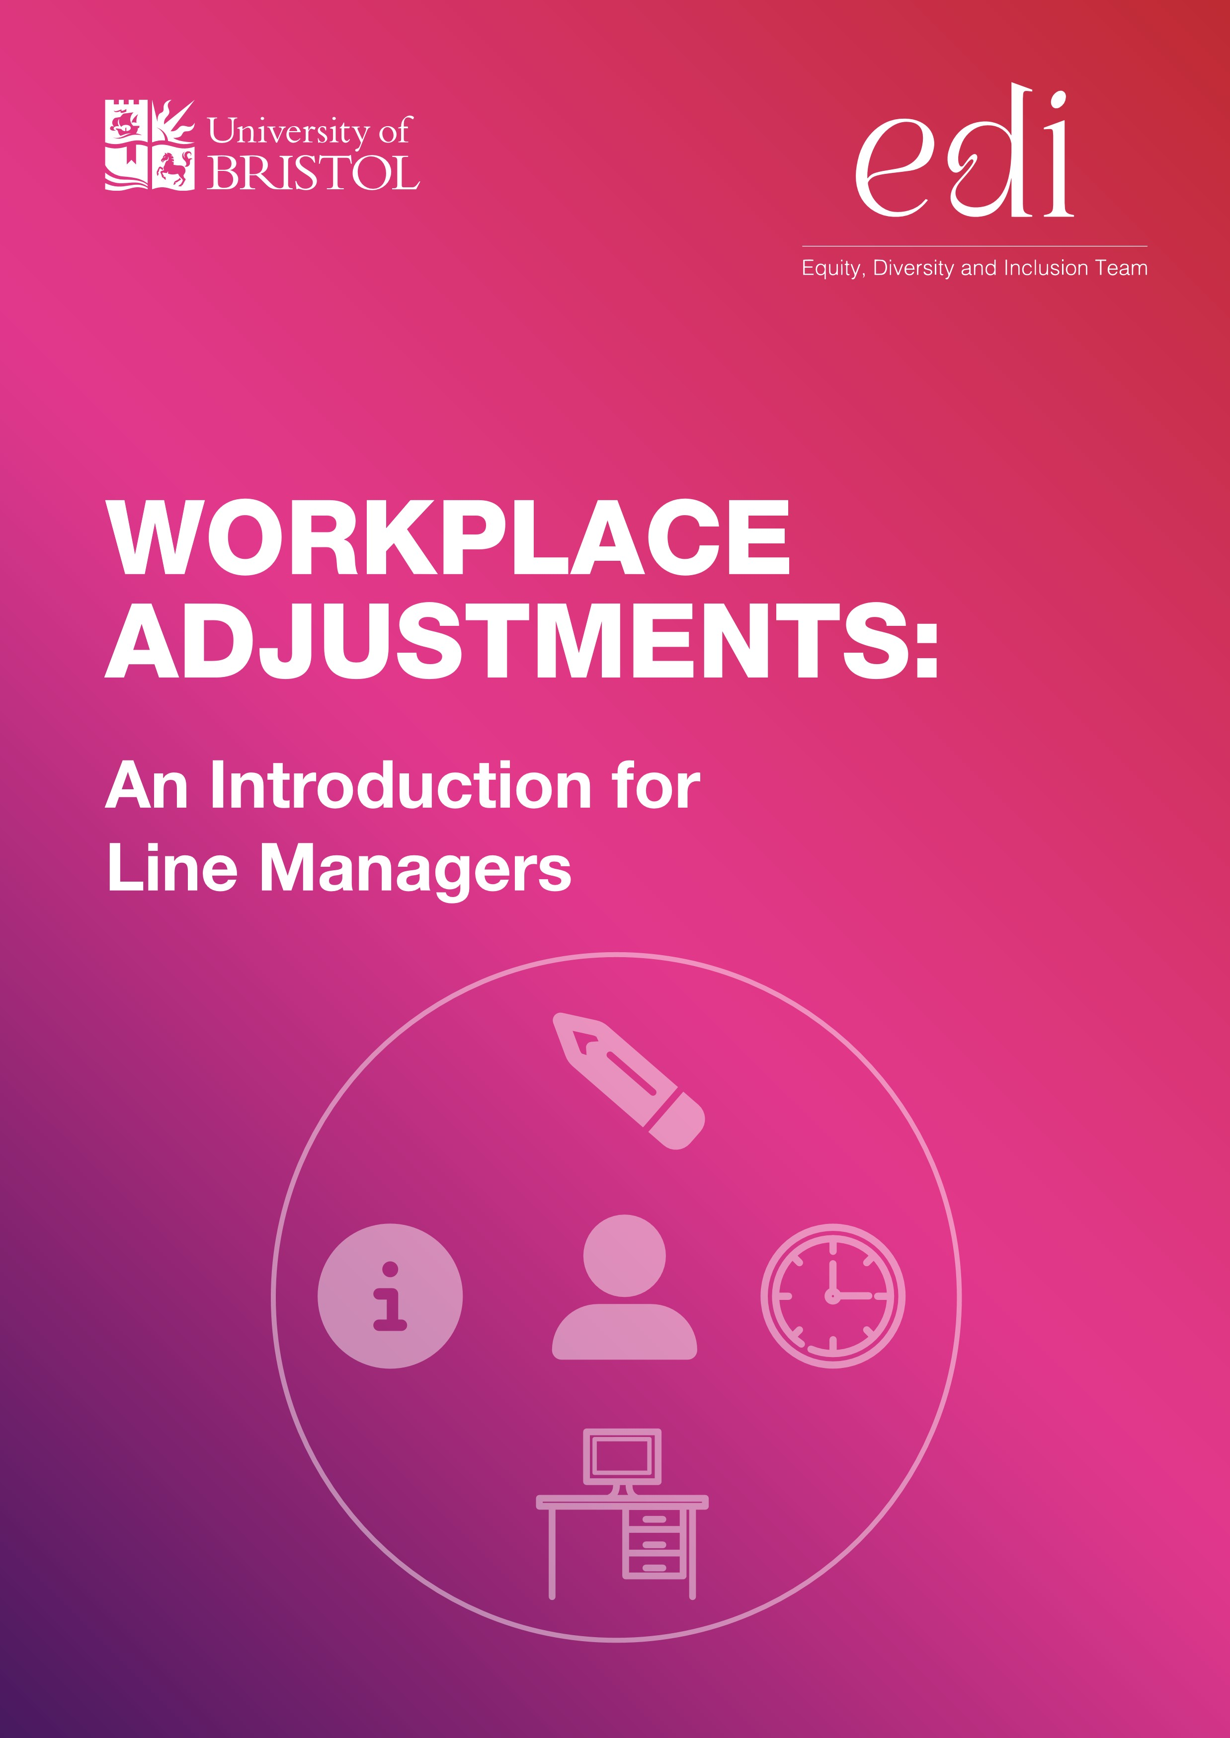

INTRODUCTION
One billion people, or 15% of the world’s population, experience some form of disability, and disability prevalence is higher for developing countries. There are 16 million disabled people in the UK, and 23% of working age adults are disabled. It’s estimated that 5 million disabled people are in work, however, there are still barriers that prevent disabled people from entering employment. The employment rate of disabled people is 53% compared to 82% of non-disabled people. This represents a huge pool of untapped talent and reinforces the need for us to ensure that we create an authentically inclusive environment where everyone can belong and progress their careers.
Line managers have a vital role in creating an open and inclusive work culture, based on trust and respect. This means having regular one-to-ones with staff, being comfortable having sensitive conversations and asking how people are on a regular basis. If people in your team (or those joining you) know you have a positive approach to equity and inclusion, they will be much more likely to tell you about the barriers that they face and the adjustments that are needed.

THE LEGAL CONTEXT
The Equality Act 2010 makes it unlawful for an employer to discriminate against a disabled person at any point of the employee lifecycle, from recruitment and induction through to training, development, progression and promotion. Annex A provides guidance on reasonable adjustments during the recruitment process for hiring managers.
The Act defines a disability as a ‘physical or mental impairment’ which has a ‘substantial’ and ‘long-term adverse effect’ on a person’s ability to carry out ‘normal day-to-day activities’. This covers a wide range of people and impairments, some of which may not be immediately obvious or visible. For example, around 20% of the UK population identify as neurodivergent.
Employers also have a duty under the Equality Act to make ‘reasonable adjustments’ to remove any barriers that a person may experience in the recruitment process or within the workplace. An employer failing to make ‘reasonable adjustments’ for a disabled job applicant or employee is one of the most common types of disability discrimination.
There are some factors which employers might want to consider when deciding which adjustments are reasonable:
- How effective the change will be in removing, reducing, or preventing the barrier someone may experience.
- The practicality of making the adjustment.
- The cost of the adjustment.
- The employer’s resources and size.
- The availability of external financial assistance.
Determining if a person meets the definition of disability is a complex legal decision. The Equality and Human Rights Commission Statutory Code of Practice states:
‘In order to avoid discrimination, it would be sensible for employers not to attempt to make a fine judgement as to whether a particular individual falls within the statutory definition of disability, but to focus instead on meeting the needs of each worker’.

THE SOCIAL MODEL OF DISABILITY
We know that people view disability differently and have their own views on so called models of disability, however our approach to disability inclusion centres around the social model of disability. This means we focus on how people are ‘disabled’ by barriers in society, rather than by their impairment or difference. In contrast, the medical model says people are disabled by their impairments or differences. This looks at what is ‘wrong’ with the person, rather than what they need, suggesting that the problem is with the disabled person.
In following the social model, we use the terms ‘disabled people’ or ‘disabled person’ (to reflect the shared, disabling experience that people with impairments face in society), rather than the terms ‘people with disabilities’ or ‘person with a disability’, but we respect other people’s language choices.
Using the social model helps identify the barriers that disabled colleagues may face in the workplace. The social model recognises that, from a disabled person’s perspective, the problems they face are the barriers they experience in the workplace and in wider society. We expect managers to remove or reduce these barriers by making workplace adjustments wherever possible.

WORKPLACE ADJUSTMENTS
Certain aspects or conditions of a job or the workplace can represent a barrier for disabled colleagues, which can mean they are disadvantaged. As explained in Section 2 employers have a duty to make ‘reasonable adjustments’ for disabled people to help remove that disadvantage.
Adjustments are changes that are made to the work environment, or the way the work is carried out, so that colleagues can do their job more effectively. Workplace adjustments can include:
- a more flexible working arrangement, for example, allowing someone to work from home or changing their hours so that they can avoid travelling at peak times
- arranging more one-to-one supervision, additional training, or providing a mentor
- making a physical change to the workplace or workstation, for example, changing a desk height, or moving office furniture to improve access
- providing extra equipment or assistance, for example, a new chair or specific software
- accommodating preferred modes of communication
- scheduling breaks in meetings
For many disabled people, workplace adjustments are the single most important factor that help them to remain in work. It’s important to note that:
- Not all adjustments relate to the physical working environment, such as wheelchair ramps. Many adjustments are less tangible, but just as important, such as changing work hours or increasing one-to-one supervision. An adjustment is only reasonable if it is effective in removing the disadvantage that the disabled person is facing.
- Adjustments are not about reducing performance standards or expectations, but about introducing support to ensure that the individual is able to meet those standards and expectations.
- Where no adjustment can be identified to enable an individual to do their job, it may be necessary to explore redeployment to a more suitable, alternative role as a reasonable adjustment.
- It may be justifiable and lawful to refuse a request if it can be shown the changes are not reasonable, for example, they would be prohibitively expensive (within the context of the financial resources available to the whole University).
- In the event of a claim for breach of the duty to make reasonable adjustments, an Employment Tribunal will ultimately decide what adjustments should be made and whether the employer was justified in refusing to make an adjustment.
The University’s Ill Health Policy provides a framework for managers to follow where individuals experience difficulty in fulfilling the required standards of a role due to an underlying health condition, even if the employee is not absent from work. You should ensure that the individual is aware that you are supporting them within the parameters of that Policy.
Ultimately, the aim of the reasonable adjustment duty is to remove barriers to employment and create an inclusive and supportive working environment. As such, workplace adjustments should be flexible and adaptable to meet the changing needs of employees over time. As a line manager, you should therefore have regular meetings to review the adjustments that have been put in place to check they are effective or whether they need to be modified.
Where there are costs that do not fall within the general expectations of what is reasonable for an employer to provide, financial support may be available for individuals through, for example, the government’s Access to Work scheme.

ACCESS TO WORK
Access to Work is a publicly funded employment support grant scheme that provides practical and financial support to enable disabled people to start or stay in work. A formal diagnosis is not required, though it is recommended.
Disabled colleagues make a direct application for support – line managers cannot apply on their behalf - which could include, but is not limited to:
- specialist equipment and assistive software
- adaptations to vehicles costs of travelling to work if public transport is not an option
- support workers, such as a British Sign Language interpreter or job coach
- physical changes to the workplace
This support must be ‘over and above what a non-disabled person would need to do their job’. Access to Work does not provide the support itself but provides a grant towards the agreed cost of the support that is needed.
It is essential that line managers ensure that all new starters are aware of Access to Work as usually 100% of costs are covered if applications are made within the first six weeks of employment. Where applications are made more than six weeks after the start date, it is likely that costs will be shared with the University.
Where IT equipment and software is recommended, it is important to contact IT Services to ensure compatibility with University systems and to explore if any current provision can provide the required level of support. University preferred suppliers may be used instead of those recommended by Access to Work.
Access to Work also provides a Workplace Mental Health Support Service which can be accessed from Able Futures or Maximus. This provides nine months of tailored mental health support to employees who are experiencing depression, anxiety or stress to help them stay in, or return to, the workplace, at no cost to the individual or employer.
More information is available on the central EDI Team’s web pages.

PROCESS FOR MAKING WORKPLACE ADJUSTMENTS
This process provides a structured and consistent framework for implementing workplace adjustments on the basis that line managers will typically be the first point of contact if adjustments are required. Where a request for an adjustment is made, line managers should schedule time with the individual to discuss the support required and the difficulties experienced. Engaging in dialogue with the individual means that they have an opportunity to provide their thoughts on what will assist them in doing their job and to work in partnership with their line manager to identify effective adjustments.
- Encourage the individual to complete a Workplace Adjustment Plan to help frame this discussion. The Plan provides a structure for an employee to have a confidential conversation with their line manager about workplace adjustments, capturing relevant information.
- If costs are involved in making the reasonable adjustments, the line manager should have a conversation with their budget holder to ensure that financial support can be provided.
- If there are costs involved that would go ‘over and above what a non-disabled person would need to do their job’, or if the individual is new to the University, encourage them to make an application for Access to Work funding or to access workplace mental health support services.
- Always consult with IT Services before purchasing any specialist IT software or hardware to ensure compatibility with University systems and to check if there is already existing provision that will meet the need. IT Services can also advise on approved suppliers.
- If adjustments are difficult to identify, the line manager contacts their HR Business Partnering Team for specialist advice. The HR Business Partnering Team may also coordinate the involvement of experts, such as the University’s Occupational Health Service to help identify adjustments. Any recommendations made by Occupational Health should then be considered in terms of what is reasonable to implement. In complex cases or where there is uncertainty over what is
‘reasonable’, the HR Business Partnering Team can seek expert advice from the Head of the central EDI Team.
- In the interests of confidentiality, discuss if and how any agreed adjustments should be communicated to other members of the team and do not share any details of the nature of the disability without the consent of the individual.
- The line manager and the employee regularly review and monitor the adjustments to ensure they remain effective and to make any necessary changes.
- The outcome of these discussions can be recorded on a Workplace Adjustment Plan if the individual is happy to use this. Where an employee has a change of line manager, the completed Plan can be shared with them, confidentially and with the individual’s consent, without the need for the employee to repeat potentially difficult conversations.
- Where an individual has a change of job or work location, agreed adjustments should be reviewed to ensure they are reasonable and effective within the context of the new role.
Line managers should be alert to the signs that an employee may be disabled or be experiencing difficulties at work – such as an increase in absence, issues with work performance, difficulties in usual working activities (such as communication, memory, or time management), a change in their behaviour, or appearing to be in pain or discomfort. In such cases, talk to the individual taking an empathetic approach and without making assumptions, to understand if there are issues requiring support. You can also seek support and advice where you require it, for example from your direct line manager or from your HR Business Partnering Team.
Diagnosis does not need to be the gatekeeper to adjustments, particularly for neurodivergent employees. Try to normalise conversations with your team around what is means to be an individual in the workplace and how this means that some of us may need support to maximise our potential at work. Ultimately, it is your responsibility as a line manager to ensure that all employees – whether they are disabled or not – have the support that they need to do their job to the best of their ability.

ANNEX A REASONABLE ADJUSTMENTS: GUIDANCE FOR HIRING MANAGERS
This guidance aims to ensure that hiring managers understand their responsibilities in relation to making adjustments during the recruitment process. As central HR guidance, this process should be followed to ensure a compliant and consistent approach to making adjustments.
All candidates, internal and external, can request adjustments to any stage of the recruitment process to alleviate disadvantage due to a disability. In practice, this means taking reasonable steps to reduce or remove barriers that could negatively impact a disabled applicant’s performance.

The role of the Resourcing Team
Candidates will be asked to contact the Resourcing Team to request adjustments when invited to interview. Applicants can also ask for adjustments to the application process if there are accessibility issues. The Resourcing Team will consider each request on an individual basis, liaising with the hiring manager as appropriate. Requests for adjustments are considered on an individual basis within the context of the role and their practicality.
Where the adjustment requested is not practicable, alternative ways of ensuring the interview process is accessible should be offered wherever possible. In such cases, or where requests are complex, expert advice will be sought from the Head of Equity, Diversity & Inclusion.

The role of the hiring manager
It is the hiring manager’s responsibility to implement reasonable adjustments to support candidates at interview. This also extends to cover members of the interview panel who may themselves require adjustments.
Examples of commonly requested adjustments from candidates are provided below; however, this list is not exhaustive. Hiring managers should consider adopting the following adjustments as standard interview practice to demonstrate a proactive, rather than reactive, approach to disability inclusion.

Sharing interview questions with candidates in advance
Some candidates – particularly neurodivergent candidates - may request interview questions in advance. This can help the candidate feel more confident, as they will know what to expect. However, it is important to make them aware that there will also be flexibility for the panel to ask follow-up questions as required. On this basis, providing a clear structure for the interview in terms of the areas that will be covered will be of benefit, as the candidate will know exactly what to expect at each stage of the process. It is worth sharing this ‘interview agenda’ with all candidates as standard best practice so that everybody knows what to expect on the day.

Modifying whether the interview is held on-line or in-person
Virtual interviewing can make it more inclusive for many groups and may offer a more flexible option for all interviewees. As well as providing flexibility for disabled candidates, this can also benefit interviewees who may have time and budgetary constraints, including those with caring responsibilities or those who may be on parental leave. However, it is also important to be aware that on-line interviews may not suit everyone, and some selection practices or roles may not be appropriate for an on-line process.
Where the demands of the role do not require the candidate to attend in person, any request for an on-line interview should be granted. If interviews are being held on-line, requests for holding an interview in-person instead should also be considered, as online interviews may not be accessible for all candidates. Interview panel members should adhere to guidance on disrupting bias to ensure that they do not inadvertently favour inperson candidates over those who attended remotely.

Flexibility of dates and times
Candidates may request a different time or date for the interview. Routinely offering alternative timeslots wherever possible maintains the accessibility and inclusivity of our processes. If the request cannot be met, be clear on the reasons why this is not possible. For example, due to the availability of the panel members, or where this would significantly delay the outcome for other candidates.

Allowing communication support at interview
Candidates may require communication support during the interview, such as a British Sign Language interpreter. Resourcing will advise the candidate to apply for Access to Work to cover costs. When conducting an interview that involves communication support, the focus of the panel should remain on the candidate, and not on the support worker.

Adapting tests at interview
Being clear on the purpose of any test that you are including at interview, and on the job requirement that this is designed to test, is important. This will enable you to determine if the test is needed, or if there are other more inclusive ways that this experience might be demonstrated. For example, could the candidate discuss how they would approach a specific task, rather than being asked to complete the task within a set time? Candidates may also request specialist software, equipment and/or extra time to alleviate any disadvantage they may experience in attempting to complete the task to a required standard during interview.

Supporting neurodivergent candidates
Traditional interview processes can be particularly challenging for neurodivergent candidates. CIPD has developed the following tips that should be considered during conventional interviews, many of which reflect ‘universal accommodations’ and are, in essence, general good people management practice:
Recognise that interviews are generally more a test of social competence than ability to perform specific job tasks of a particular role.
Provide the candidate in advance with clear communication about how to get to the interview venue (preferably with visual clues) and what to expect in the interview – including who they will meet, the length and format of the interview – and choose a suitable, quiet space free from distractions.
Be aware of the bias of ‘first impressions’ and avoid penalising unconventional body language or an apparent lack of social interaction skills.
Ask direct, specific questions rather than questions based on conjecture.
Avoid rapid fire questions from multiple interviewers as this can cause stress and anxiety, be off-putting and hard to follow.
Be prepared to facilitate in the interview if necessary – for example, if an interviewee’s answers are informative, but too long, it’s fine to gently cut them off and say ‘thank you, you have told us enough about that now – I’d like to ask you a different question now’.

ANNEX B

References
- Neuroinclusion at work report 2024 (cipd.org)
- Access to Work: staff guide - GOV.UK (www.gov.uk)
- Neurodiversity at work (cipd.org)
- Disability Inclusion Overview (worldbank.org)
- Family Resources Survey: financial year 2021 to 2022 - GOV.UK (www.gov.uk)
- Equality Act 2010: guidance - GOV.UK (www.gov.uk)
- Recruiting, managing and developing disabled people: a practical guide for managers - GOV.UK (www.gov.uk)
- The Social Model of Disability - Inclusion London
- Access to Work: get support if you have a disability or health condition - GOV.UK (www.gov.uk)
- Reasonable Adjustments: Guide for Employers - DavidsonMorris

n
bristol.ac.uk/inclusio
If you need all or part of this
publication in an alternative
format please contact the Equity,
Diversity and Inclusion Team:
Email
edi-team@bristol.ac.uk

